**USE CASED DIAGRAM**

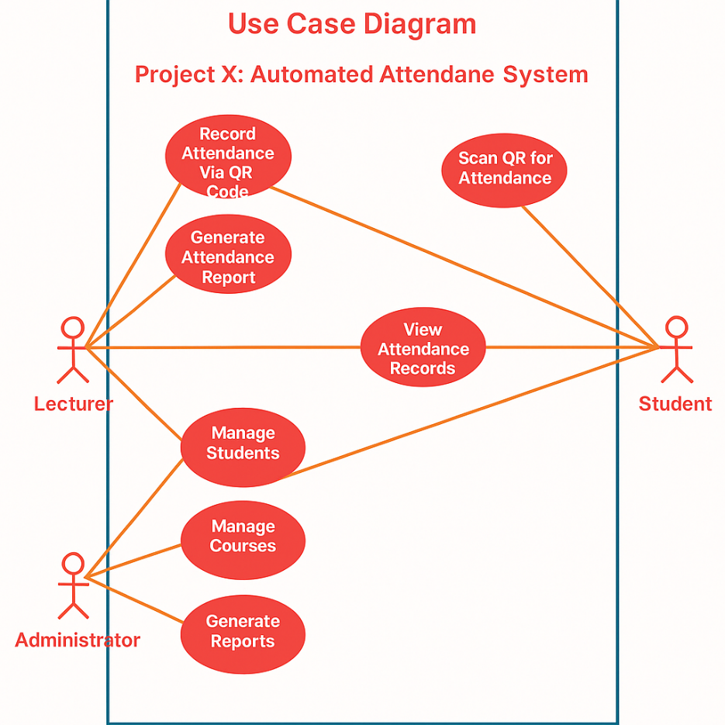

**Scenario:**

1. **Lecturer logs in and generates a QR Code for today’s class session.**
2. **Student scans the QR Code, triggering the system to verify identity and geolocation.**
3. **Attendance is recorded automatically.**
4. **Admin reviews the logs and generates reports on attendance trends for auditing or administrative decisions.**